Sprint 2 Plan

CryptoTracker

CryptoTracker Developers

February 5th, 2018

**Sprint 2 Goal:**

For sprint 2, we need to focus on setting up the base website that can call currency information.

**Task Listing/User Story:**

*User Story 1:* As a user, I want to be able to track the prices of all cryptocurrencies. (5)

* Connect just Bitcoin’s information
* Work on connecting the rest of the API so we can collect all the data

*User Story 2:* As a user, I want to view prices in an easy to read format (3)

* Create a table to display the information
* Connect the information and the table

*User Story 3:* As a user, I want be able to monitor price trends with graphs (13)

* Think of visually pleasing ideas on how to display the information
* Create said tables w/out the information
* Connect the data to the tables

**Team Roles:**

Alex Au - Product Owner/Developer

Kianna Mark -Developer

Alex Lim - Scrum Master/Developer

William Chan - Developer

Drew Caltagirone - Developer

**Initial Task Assignments:**

Alex Au - Focus on backend, User Story 1

Kianna Mark - Focus on front end, User story 2

Alex Lim - Focus on front end, User story 2

William Chan - Focus on front end, User story 3

Drew Caltagirone - Focus on backend, User Story 1

**Burnup Chart:**

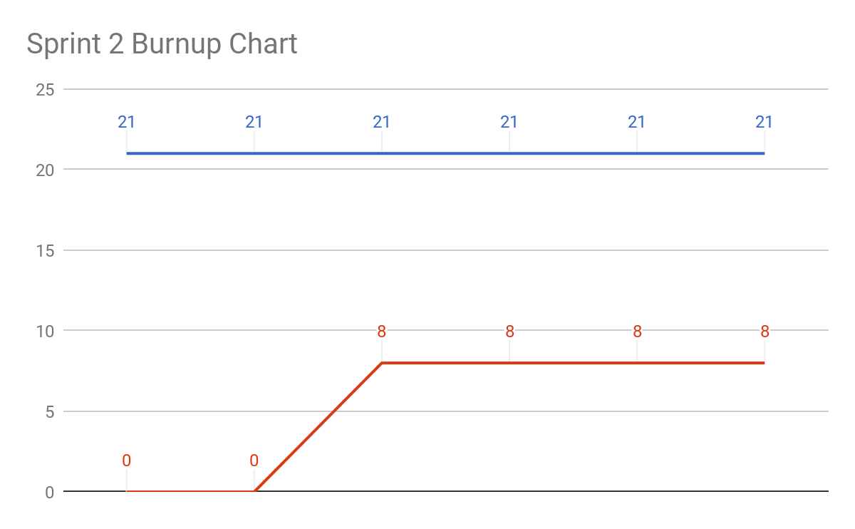

**Scrum Board:**

|  |  |  |  |
| --- | --- | --- | --- |
| **User Story** | **To Do** | **In Progress** | **Done** |
| *User Story 1:* As a user, I want to be able to track the prices of all cryptocurrencies. (5) |  | * Work on connecting the rest of the API so we can collect all the data | **-**Connect just Bitcoin’s information |
| *User Story 2:* As a user, I want to view prices in an easy to read format (3) | * Connect the information and the table | * Create a table to display the information |  |
| *User Story 3:* As a user, I want be able to monitor price trends with graphs (13) | * Create said tables w/out the information * Connect the data to the tables | * Think of visually pleasing ideas on how to display the information |  |

**Scrum Times:**

Monday 9:05-9:20AM

Wednesday 9:05-9:20AM

Friday 9:05-9:20AM